Steps for execution:
- Download python 2.7.9.
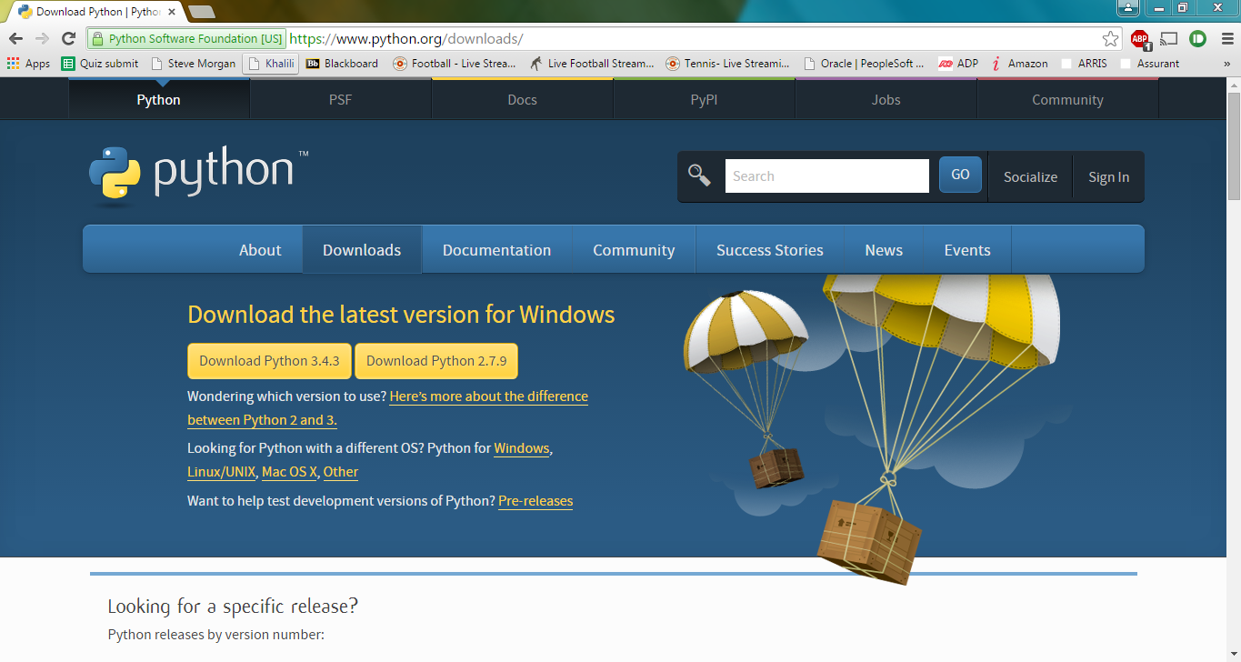
- After installation, a folder by the name Python27 will be created in the C: drive.
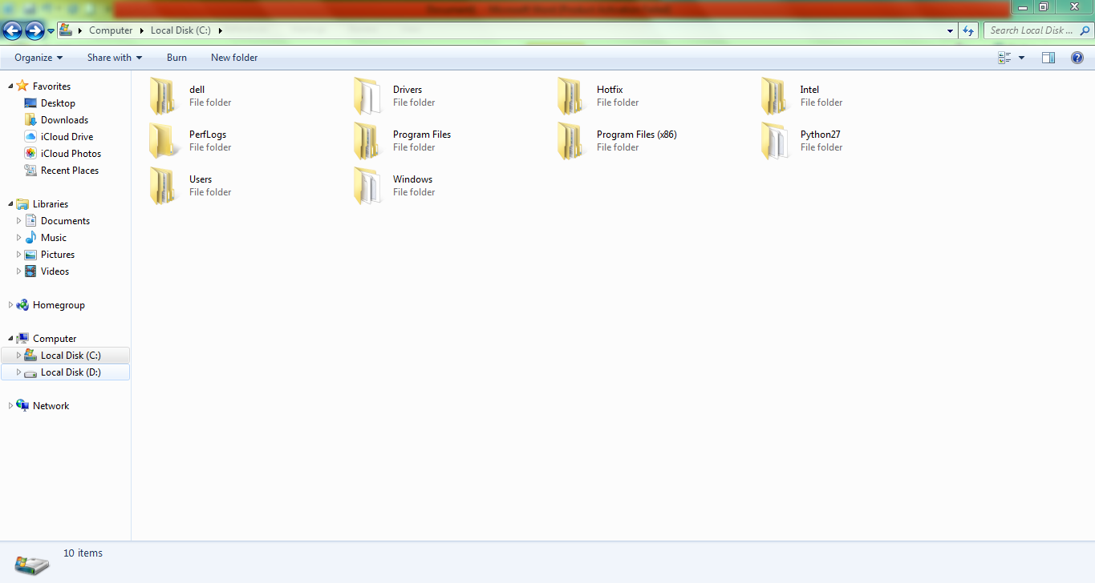
- Copy the address of the Python27 folder into the pathname of system variables in the environment variables of My Computer.
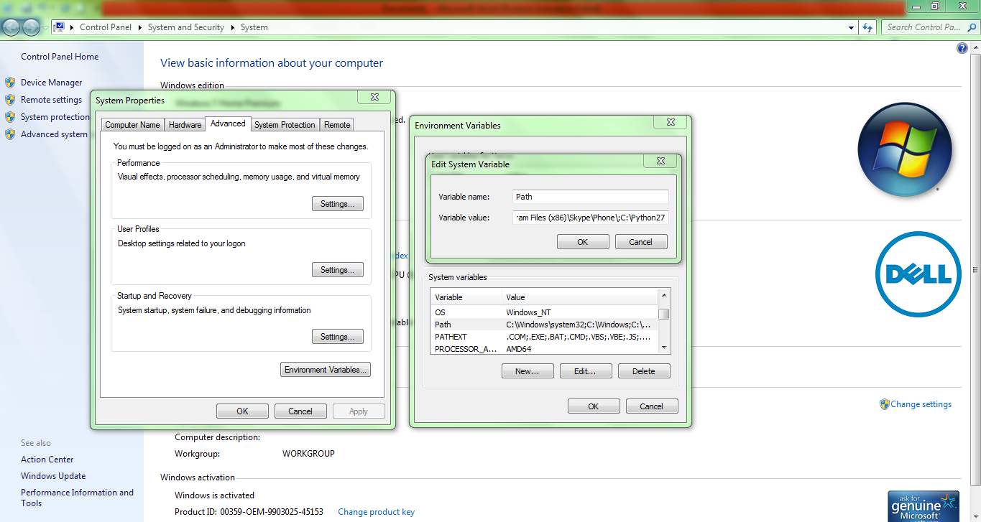
- Put the code file and the python exe file in the same folder and name it as Project.
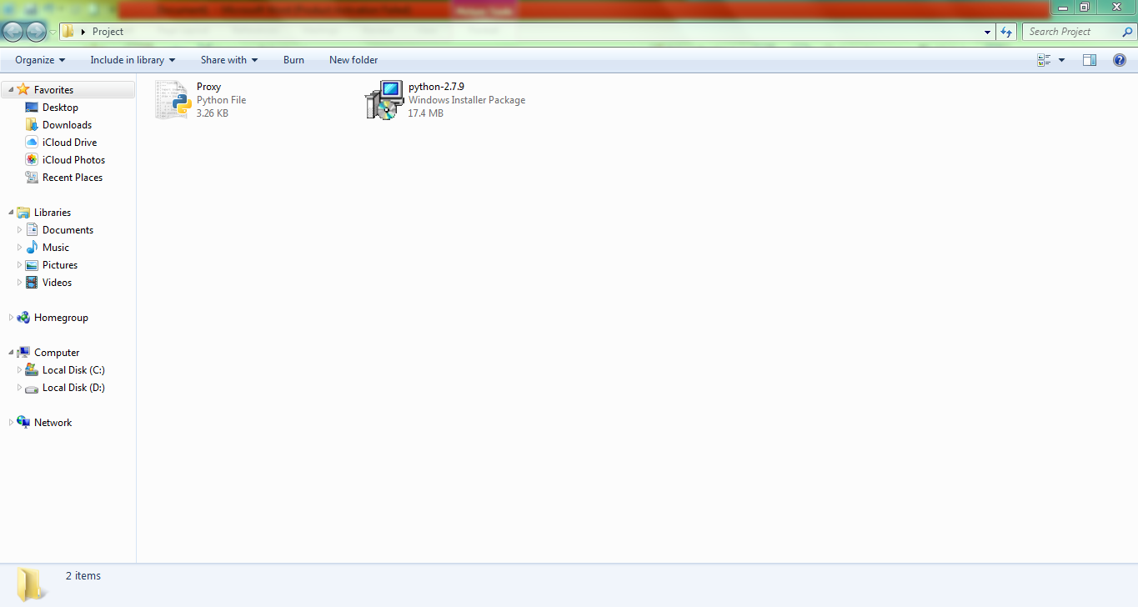
- Copy the address of the Project folder under TEMP of user variables in the environment variables of My Computer.
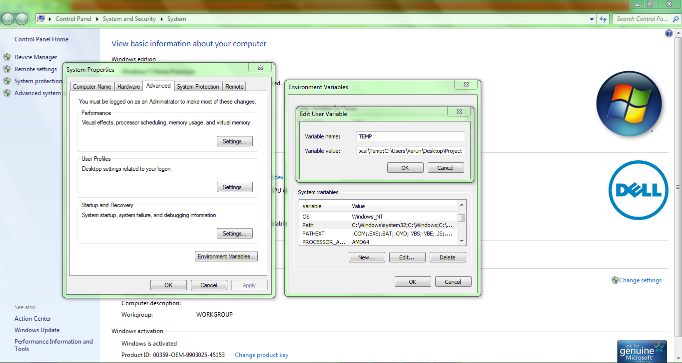
- Open the python shell command prompt and set the address to that of the Project folder.
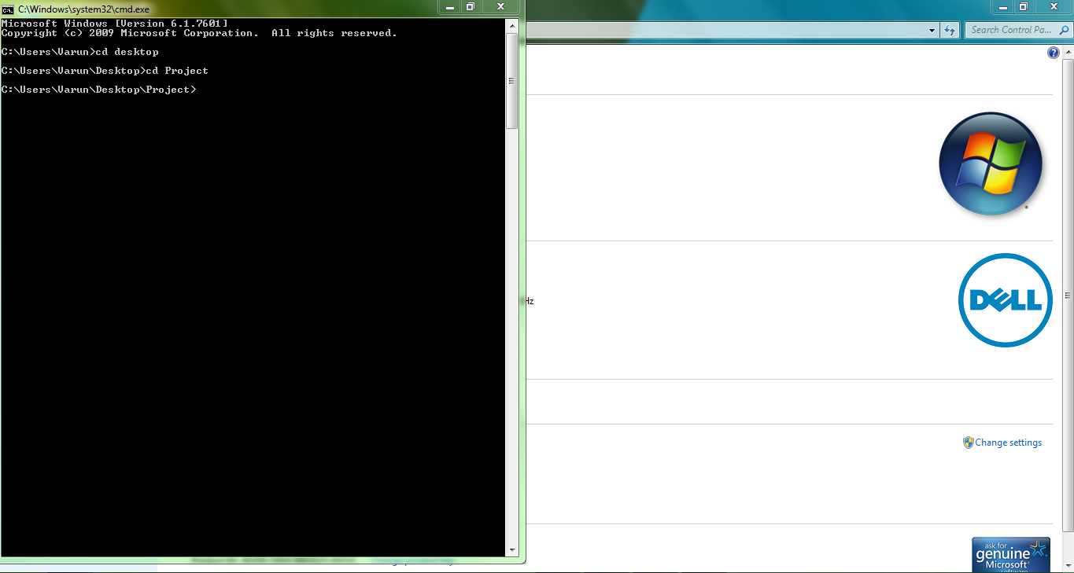
- Execute the file using the command “python Proxy.py 127.0.0.1”
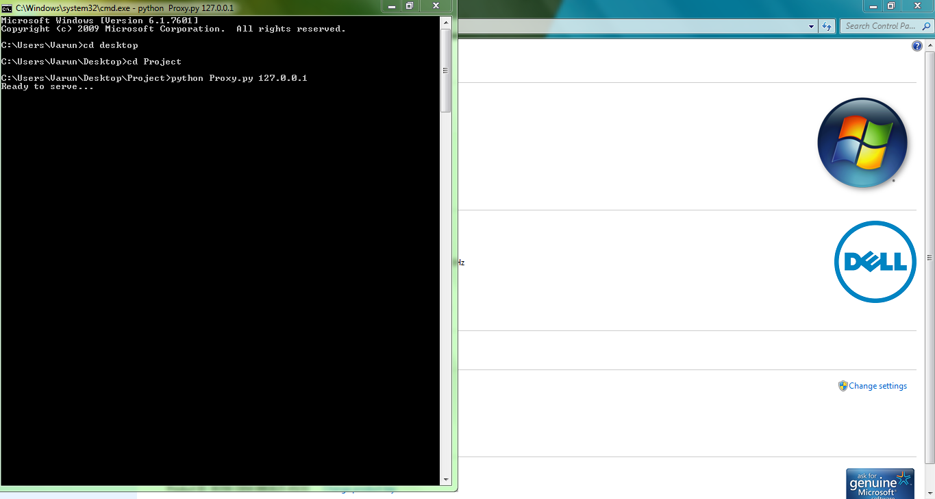
- Open a web browser and type in the URL http://127.0.0.1:8080/www.linkedin.com
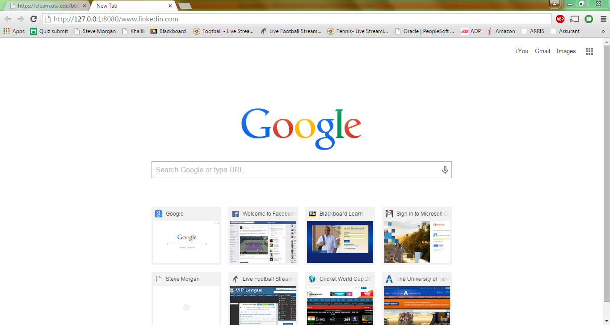


- The python shell command prompt shows the following output
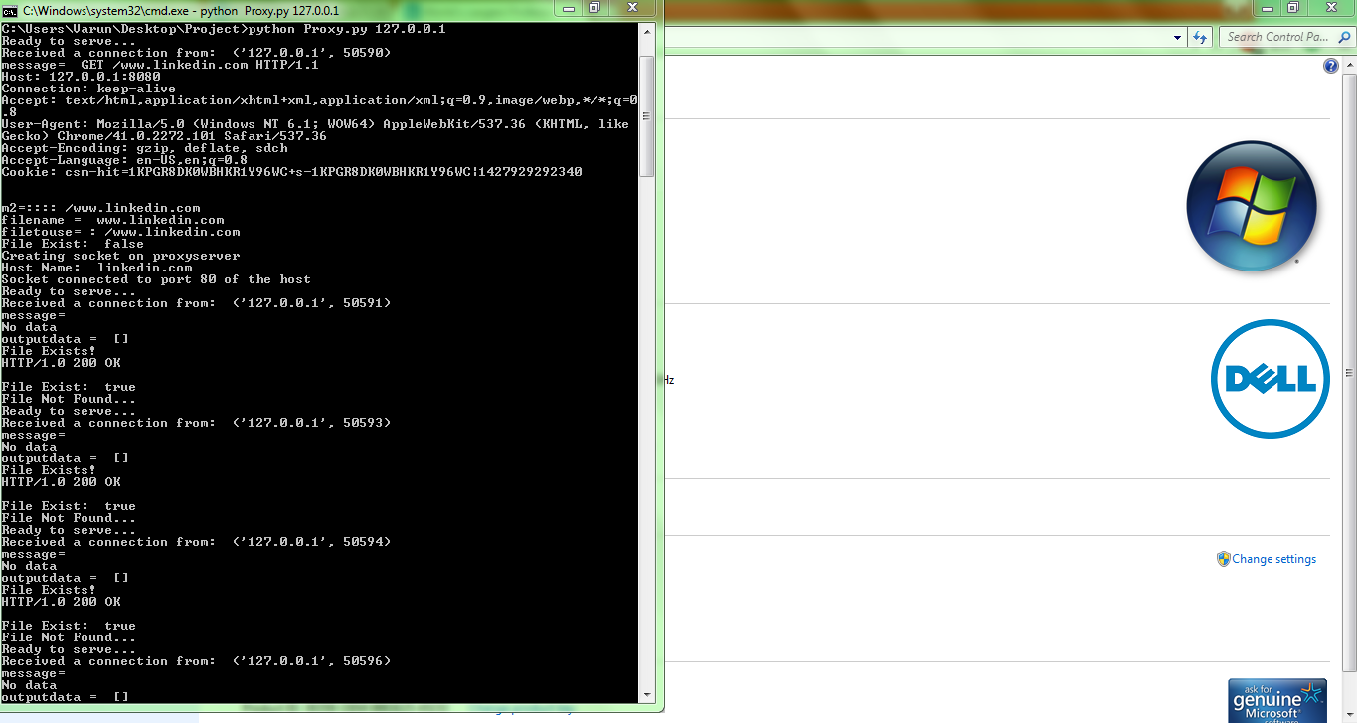

- A log.txt file and a cached linkedin MS-DOS file are created in the Project folder.
